Sample document for code project
Reading Barcodes from an Image - III
by Berend Engelbrecht, VB.Net translation by Alessandro Gubbiotti
http://www.codeproject.com/KB/graphics/BarcodeImaging3.aspx

This sample document demonstrates how the BarcodeDetection COM-interface can be used from a Microsoft Word macro (VBA).

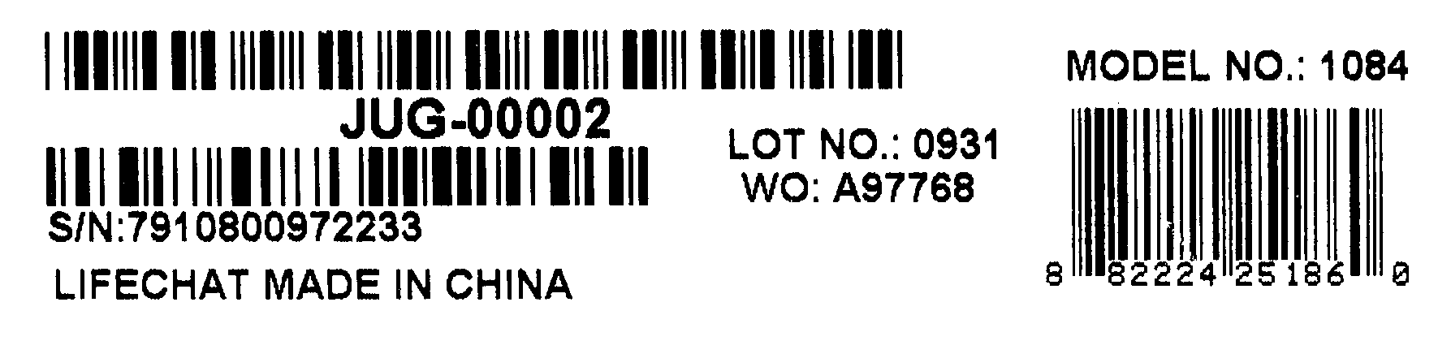

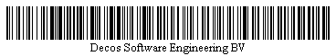

Note: Please enable macros to allow Barcode detection.

Code licensed under The Code Project Open License (CPOL).
See http://www.codeproject.com/info/cpol10.aspx

